Lab 09
Name: Azhar Soomro
CMS ID: 023-24-0521
Class: AI-B
Exercise 1:
Code:
class Message {
private String text = null;

public Message(String T) {
text = T;
}
public Message() {

}
public String toString() {
return (text);
}
public void setText(String t) {
text = t;
}

}
class Email extends Message {
private String Sender = null;
private String Reciver = null;
private String Subject = null;

public String toString() {
return ("Sender: "+Sender+" Reciver: "+Reciver+" Subject: "+Subject+" Text: "+super.toString());
}
public Email(String Reciver,String Sender,String Subject,String Text) {
this.Reciver = Reciver;
this.Sender = Sender;
this.Subject = Subject;
setText(Text);
}
}
class SMS extends Message {
private String recipientContactNo = null;

public void setRecipientContactNo(String N) {
recipientContactNo = N;
}
public String getRecipientContactNo() {
return (recipientContactNo);
}
public String toString() {
return (recipientContactNo+" "+super.toString());
}
public SMS(String N,String T) {
recipientContactNo = N;
setText(T);
}
}
class Q1 {
public static void main(String args[]) {
System.out.println("-------------------------");
System.out.println(" Excercise_1");
System.out.println("-------------------------");
SMS sms = new SMS("0300-1920233","How are you bro........?");
Email email = new Email("sender@email.com","reciver@email.com","Hi","How are you bro........?");
Message message = new Message("This is java");

System.out.println(sms);
System.out.println(email);
System.out.println(encode("This is Java zz ZZ"));
System.out.println(decode("Uijt jt Kbwb {{ [["));
System.out.println(ContainsKeyword(message,"is"));
System.out.println(ContainsKeyword(sms,"er"));
System.out.println(ContainsKeyword(email,"@"));
}
//for message
public static boolean ContainsKeyword(Message messageObject,String keyword) {
if (messageObject.toString().indexOf(keyword,0) >= 0) {
return true;
}
else {
return false;
}
} //for emial
public static boolean ContainsKeyword(Email emailObject,String keyword) {
if (emailObject.toString().indexOf(keyword,0) >= 0) {
return true;
}
else {
return false;
}
} //for sms
public static boolean ContainsKeyword(SMS smsObject,String keyword) {
if (smsObject.toString().indexOf(keyword,0) >= 0) {
return true;
}
else {
return false;
}
}
public static String encode(String a) {
char result[] = new char[a.length()];
for(int i=0; i<a.length(); i++)
{
char c = a.charAt(i);
if(c != ' ')
{
/* int as = ((int)c);
as++;
c = (char)(as);*/
c++;
}
result[i] = c;
}
String add = new String(result);
return add;
}
public static String decode(String a) {
char res[] = new char[a.length()];
for (int i =0; i<a.length(); i++) {
char c = a.charAt(i);
if (c != ' ') {
c--;
}
res[i] = c;
}
String add = new String(res);
return add;
}
}

Output:
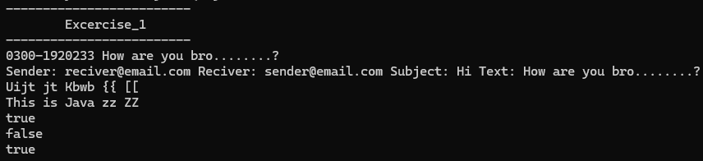

Exercise 2:

Code:
class Employee {
private String fName;
private String lName;
private String CNIC;

Employee(String fName, String lName, String CNIC){
this.fName = fName;
this.lName = lName;
this.CNIC = CNIC;
}
Employee(){}

public void setfName(String fName) {
this.fName = fName;
}
public void setlName(String lName) {
this.lName = lName;
}
public void setCNIC(String CNIC) {
this.fName = fName;
}
public String getfName(){
return fName;
}
public String getlName(){
return lName;
}
public String getCNIC(){
return CNIC;
}
public String toString( ) {
return (fName + " " + lName + " CNIC# " + CNIC);
}
public double earnings(){
return 0.00;
}
}
class SalariedEmployee extends Employee {
private double weeklySalary;

SalariedEmployee(String fName, String lName, String CNIC, double weeklySalary){
super(fName, lName, CNIC);
this.weeklySalary = weeklySalary;
}
SalariedEmployee(){}

public void setweeklySalary(double sal) {
if(sal < 0) {
System.out.print("Weekly Salary cant be negative");
}
weeklySalary = sal;
}
public double getWeeklySalary(){
return weeklySalary;
}

public String toString() {
return "\nSalaried employee: " + super.toString();
}
public double earnings() {
return weeklySalary;
}
}
class HourlyEmployee extends Employee{
private double wage;
private double hours;

HourlyEmployee(String fName, String lName, String CNIC, double wage, double hours){
super(fName, lName, CNIC);
this.wage = wage;
this.hours = hours;
}
HourlyEmployee(){}

public void setWage(double wage) {
this.wage = wage;
}
public void setHours(double hours) {
this.hours = hours;
}
public double setWage() {
return wage;
}
public double setHours() {
return hours;
}
public String toString() {
return “\nHourly employee: ” + super.toString();
}
public double earnings() {
if (hours <= 40){
return wage * hours;
}
else {
return 40*wage + (hours-40)*wage*1.5;
}
}
}
class CommissionEmployee extends Employee{
private double grossSales;
private double commissionRate;

CommissionEmployee(String fName, String lName, String CNIC, double grossSales, double commissionRate){
super(fName, lName, CNIC);
this.grossSales = grossSales;
this.commissionRate = commissionRate;
}
CommissionEmployee(){}

public void setgrossSales(double grossSales) {
this.grossSales = grossSales;
}
public void setcommissionRate(double commissionRate) {
this.grossSales = commissionRate;
}
public double getgrossSales() {
return grossSales;
}
public double getcommissionRate() {
return commissionRate;
}

public String toString() {
return "\nCommission employee: " + super.toString();
}
public double earnings() {
return grossSales * commissionRate;
}
}
class BasePlusCommissionEmployee extends CommissionEmployee{
private double baseSalary;

BasePlusCommissionEmployee(String fName, String lName, String CNIC, double grossSales, double commissionRate, double baseSalary){
super(fName, lName, CNIC, grossSales, commissionRate);
this.baseSalary = baseSalary;
}
BasePlusCommissionEmployee(){}

public void setbaseSalary(double sal) {
if(sal < 0) {
System.out.print("Base Salary cant be negative");
}
baseSalary = sal;
}
public double getbaseSalary(){
return baseSalary;
}
public String toString() {
return "\nBase plus Commission employee: " + super.toString();
}
public double earnings() {
return baseSalary + super.earnings();
}
}
public class Q2PayRollSystemTest {
public static void main (String [] args) {
Employee firstEmployee = new SalariedEmployee("Muhammad" ,"Ali","11111-1111", 800.00 );
Employee secondEmployee = new CommissionEmployee("Tarwan" ,"Kumar", "222-22-2222", 10000, 0.06);
Employee thirdEmployee = new BasePlusCommissionEmployee("Fabeeha", "Fatima", "333-33-3333", 5000 , 0.04 , 300 );
Employee fourthEmployee = new HourlyEmployee( "Hasnain" , "Ali", "444-44-4444" , 16.75 , 40);
// polymorphism: calling toString() and earning() on Employee’s reference
System.out.println(firstEmployee);
System.out.println(firstEmployee.earnings());
System.out.println(secondEmployee);
System.out.println(secondEmployee.earnings());
System.out.println(thirdEmployee);
// performing downcasting to access & raise base salary
BasePlusCommissionEmployee currentEmployee = (BasePlusCommissionEmployee) thirdEmployee;
double oldBaseSalary = currentEmployee.getbaseSalary();
System.out.println( "old base salary: " + oldBaseSalary) ;
currentEmployee.setbaseSalary(1.10 * oldBaseSalary);
System.out.println("new base salary with 10% increase is:"+ currentEmployee.getbaseSalary());
System.out.println(thirdEmployee.earnings() );
System.out.println(fourthEmployee);
System.out.println(fourthEmployee.earnings() );
} // end main
}

Output:
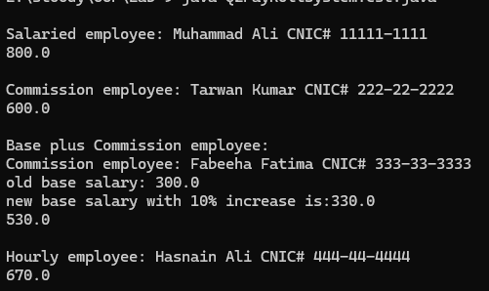

Exercise 3:

Code:
import java.util.Scanner;
public class Point {
private int x;
private int y;

public Point(int x, int y) {
this.x = x;
this.y = y;
}

public int getX() {
return x;
}
public int getY() {
return y;
}

public double distanceTo(Point p) {
int dx = x - p.getX();
int dy = y - p.getY();
return Math.sqrt(dx * dx + dy * dy);
}

public String toString() {
return "(" + x + ", " + y + ")";
}
}
public class Shape {
Point center;

public Shape(Point center) {
this.center = center;
}

public Point getCenter() {
return center;
}

public boolean contains(Point p) {
return false; // will be overridden manually in subclasses
}

public double getArea() {
return 0; // will be overridden manually in subclasses
}
}
public class Circle extends Shape {
private int radius;

public Circle(Point center, int radius) {
super(center);
this.radius = radius;
}

public int getRadius() {
return radius;
}

public boolean contains(Point p) {
return center.distanceTo(p) <= radius;
}

public double getArea() {
return Math.PI * radius * radius;
}

public String toString() {
return "Circle with center " + center + ", radius " + radius;
}
}
public class Rectangle extends Shape {
private int length;
private int width;

public Rectangle(Point center, int length, int width) {
super(center);
this.length = length;
this.width = width;
}

public int getLength() {
return length;
}

public int getWidth() {
return width;
}

public boolean contains(Point p) {
int dx = Math.abs(p.getX() - center.getX());
int dy = Math.abs(p.getY() - center.getY());
return dx <= length / 2 && dy <= width / 2;
}

public double getArea() {
return length * width;
}

public String toString() {
return "Rectangle with center " + center + ", length " + length + ", width " + width;
}
}
public class ShapesArray {
private Shape[] shapesList;
private int nShapes;

public ShapesArray(int size) {
shapesList = new Shape[size];
nShapes = 0;
}

public boolean addShape(Shape s) {
if (nShapes < shapesList.length) {
shapesList[nShapes++] = s;
return true;
}
return false;
}

public void displayRectsInfo() {
for (int i = 0; i < nShapes; i++) {
if (shapesList[i] instanceof Rectangle) {
System.out.println(shapesList[i]);
}
}
}

public int getCircleCounter() {
int count = 0;
for (int i = 0; i < nShapes; i++) {
if (shapesList[i] instanceof Circle) {
count++;
}
}
return count;
}

public double getAvgAreas() {
if (nShapes == 0) return 0;
double total = 0;
for (int i = 0; i < nShapes; i++) {
total += shapesList[i].getArea();
}
return total / nShapes;
}

public void removeAllRect() {
int j = 0;
for (int i = 0; i < nShapes; i++) {
if (!(shapesList[i] instanceof Rectangle)) {
shapesList[j++] = shapesList[i];
}
}
nShapes = j;
}
}
public class Q3TestShape {
public static void main(String[] args) {
Scanner sc = new Scanner(System.in);
ShapesArray shapes = new ShapesArray(20);

while (true) {
System.out.println("\n1. Add new shape");
System.out.println("2. Display all rectangles");
System.out.println("3. Display average shapes area");
System.out.println("4. Display number of circles");
System.out.println("5. Remove all rectangles");
System.out.println("6. Exit");
System.out.print("Choose: ");
int choice = sc.nextInt();

if (choice == 1) {
System.out.println("a. Rectangle");
System.out.println("b. Circle");
System.out.print("Choice: ");
char ch = sc.next().charAt(0);

if (ch == 'a') {
System.out.print("Enter center x y: ");
int x = sc.nextInt(), y = sc.nextInt();
System.out.print("Enter length and width: ");
int l = sc.nextInt(), w = sc.nextInt();
shapes.addShape(new Rectangle(new Point(x, y), l, w));
} else if (ch == 'b') {
System.out.print("Enter center x y: ");
int x = sc.nextInt(), y = sc.nextInt();
System.out.print("Enter radius: ");
int r = sc.nextInt();
shapes.addShape(new Circle(new Point(x, y), r));
}
} else if (choice == 2) {
shapes.displayRectsInfo();
} else if (choice == 3) {
System.out.println("Average area = " + shapes.getAvgAreas());
} else if (choice == 4) {
System.out.println("Number of circles = " + shapes.getCircleCounter());
} else if (choice == 5) {
shapes.removeAllRect();
System.out.println("All rectangles removed.");
} else if (choice == 6) {
System.out.println("Bye!");
break;
} else {
System.out.println("Invalid option.");
}
}
}
}

Output:
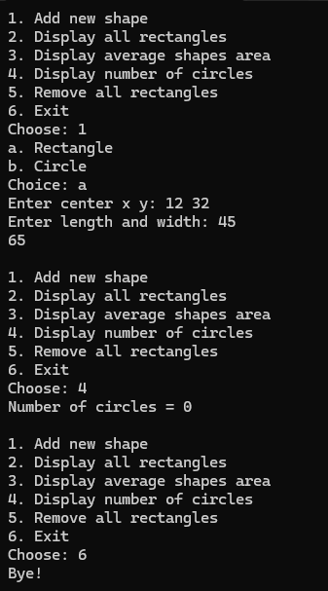

Exercise 4:

Code:
class Maths {
public void display(){
System.out.print("Hello im display of class Maths");
}
}
class Algebra extends Maths {
public void display() {
System.out.print("Hello im display of class Algebra");
}
}
class Q4{
public static void main(String args[]) {
Maths m = new Algebra();
m.display();
}
}

Output:

Exercise 5:

Code:
class Animal{
String name;
int age;
String gender;
Animal (String name, int age, String gender) {
this.name = name;
this.age = age;
this.gender = gender;
}
public void produceSound(){
System.out.print("USELESS");
}
}
class Dog extends Animal{
Dog(String name, int age, String gender) {
super (name, age, gender);
}
public void produceSound(){
System.out.println("DOG SOUNDS IDK");
}
}
class Frog extends Animal{
Frog(String name, int age, String gender) {
super (name, age, gender);
}
public void produceSound(){
System.out.println("FROG SOUNDS");
}
}
class Kitten extends Animal{
Kitten(String name, int age) {
super (name, age, "Female");
}
public void produceSound(){
System.out.println("CAT SOUNDS BUT HIGH PITCHED");
}
}
class TomCat extends Animal{
TomCat(String name, int age) {
super (name, age, "Male");
}
public void produceSound(){
System.out.println("CAT SOUNDS BUT LOW PITCHED");
}
}
class Q5AnimalSoundDemo {
public static void main(String args[]) {
Animal[] an = {
new Dog("D1", 10, "Male"),
new Dog("D2", 15, "Male"),
new Dog("D3", 12, "Female"),

new Frog("F1", 4, "Male"),
new Frog("F2", 1, "Male"),
new Frog("F3", 2, "Female"),

new Kitten("K1", 9),
new Kitten("K2", 10),
new Kitten("K3", 3),

new TomCat("T1", 17),
new TomCat("T2", 16),
new TomCat("T3", 9)
};

int dogCount = 0, frogCount = 0, kittenCount = 0, tomcatCount = 0;
int dogAgeSum = 0, frogAgeSum = 0, kittenAgeSum = 0, tomcatAgeSum = 0;

for (Animal animal : an) {
if (animal instanceof Dog) {
dogCount++;
dogAgeSum += animal.age;
} else if (animal instanceof Frog) {
frogCount++;
frogAgeSum += animal.age;
} else if (animal instanceof Kitten) {
kittenCount++;
kittenAgeSum += animal.age;
} else if (animal instanceof TomCat) {
tomcatCount++;
tomcatAgeSum += animal.age;
}
}

System.out.println("Average age of Dogs: " + (dogCount > 0 ? (double)dogAgeSum / dogCount : 0));
System.out.println("Average age of Frogs: " + (frogCount > 0 ? (double)frogAgeSum / frogCount : 0));
System.out.println("Average age of Kittens: " + (kittenCount > 0 ? (double)kittenAgeSum / kittenCount : 0));
System.out.println("Average age of Tomcats: " + (tomcatCount > 0 ? (double)tomcatAgeSum / tomcatCount : 0));
}
}
Output:
